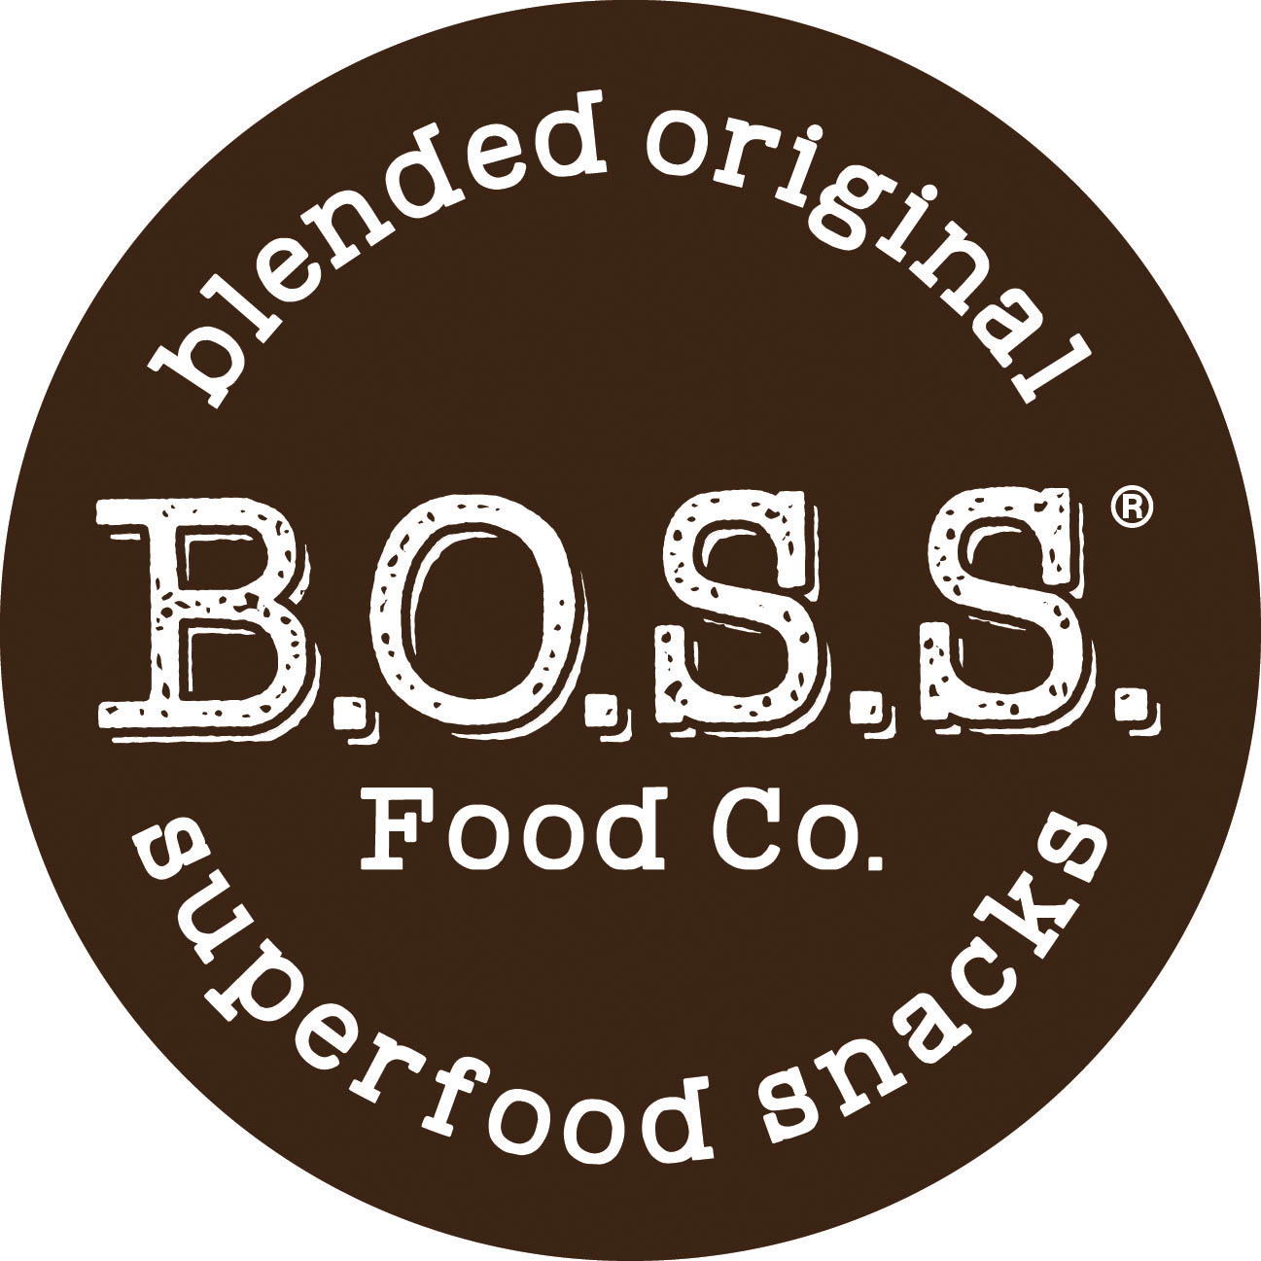

N E WS R E L E A S E
For Immediate Release

Contact: Sue Engelhart, Sue Engelhart & Associates Expo West
941-350-4735, sueengelhart5@gmail.com Booth N2241
Fact sheet on the three bars included on page 3.

B.O.S.S. REFORMULATES THREE SUPERFOOD BARS TO BOOST PROTEIN, MCT FATS, FIBER AND CUT SUGAR
The three bars are formulated with clinically researched functional ingredients
and have no added sugar. They are being introduced at Expo West, Booth N2241.

HOUSTON, Jan. 17, 2019 – B.O.S.S. Food Co.® has reformulated three of its superfood bars to gain additional nutritional benefits from newer clinically-researched functional ingredients with significant increases in vegan protein, up to three times more prebiotic fiber and no added sugar. The bars are being introduced at Expo West, Booth N2241.

The reformulated bars contain between seven and 10 grams of complete protein, an increase of up to six additional grams from fermented shiitake vegetable protein containing all 20 amino acids, said Andrea Spirov, B.O.S.S. founder and CEO. The vegan protein is derived from brown rice and pea protein fermented with shiitake mushrooms. The non-GMO, paleo and grain-free B.O.S.S. bars also have only 3- to 7-grams of sugar, all naturally occurring from fruit. The Move and Smile bars previously had 2 grams of added sugars.

The new bars also now contain medium chain triglyceride (MCT) oil. MCTs are beneficial fats that provide quick energy, feelings of satiety, assist athletic performance by decreasing lactate buildup, are linked to brain health and have fewer calories than other fats. MCTs also have been associated with optimizing beneficial gut bacteria and work with newly added prebiotic tapioca fiber in the reformulated bars to feed beneficial gut bacteria, Spirov said. The bars now have from 6 to 9 grams of fiber, an increase of up to 6 grams. All three are free from caffeine, other stimulants and performance enhancing drugs.

The three reformulated bars include the Move Fit Energy™ bar with functional ingredients selected for sports nutrition, workout fuel, post-workout recovery and energy without stimulants. It now contains an ancient peat and apple extract clinically shown to build ATP, the body’s own energy-boosting compound. The Think Brainpower™ bar for cognitive performance, attention and concentration has a newly added spearmint extract clinically shown to help with multitasking and concentration. The Smile Upbeat Focus™ bar has raw cacao for mood lift and provides five-hour focus without caffeine jitters or an energy crash with an added galanga extract clinically shown to enhance mental alertness and focus.

Pre-orders will be taken at Expo West, and the reformulated bars will be available in the second quarter.

“We only use nutrient-dense superfood ingredients, and with the new fermented shiitake vegetable protein, our customers get a high-quality, complete vegan protein with a neutral taste that doesn’t overwhelm those flavorful ingredients,” Spirov said. “Our label is very clean, and we are serious about good nutrition as a path to better health. We plan to continue evaluating newer, clinically studied ingredients like the vegan protein, particularly those that are environmentally sustainable.”

All of the plant-based B.O.S.S. energy bars combine ingredients that research indicates have similar beneficial nutritional properties. The line also includes Restore, which promotes detoxification and immune support, and Dazzle to promote beautiful hair, skin and nails. The bars are free from major allergens including soy, dairy, grains, peanuts and sugar alcohols. Ingredients include nutrient-dense superfoods like blueberries, walnuts, almonds, hemp seeds, aronia berries, maqui berries, noni fruit, rooibos tea and raw cacao powder.

Suggested retail price for the 1.7-ounce bars is $2.99 to $3.99, and they ship 12 to a case and 144 to a master case. More information about B.O.S.S. is available by calling 800-344-8584 and at bossfoodco.com.

About B.O.S.S. Food Co.:
Houston-based B.O.S.S. Food Co.® produces superfood bars with eight simple ingredients per bar. B.O.S.S., which stands for blended original superfood snacks, has a line of five plant-based functional energy bars that are non-GMO, paleo and grain free. The bars are crafted with ingredients that work together to taste great and combine ingredients that research indicates have similar beneficial nutritional properties. Andrea Spirov founded the company in 2015 after changing to a cleaner diet and lifestyle helped her overcome a number of major health challenges and initially sold the bars locally at farmers markets. She launched the line in the wholesale market in 2017. B.O.S.S. Bars are available at retailers in 10 states. More information about B.O.S.S. is available by calling 800-344-8584, at bossfoodco.com, or by connecting on facebook.com/bossfoodco, instagram.com/bossfoodco, twitter.com/bossfoodco, and pinterest.com/ bossfoodco.
###
MOVE®, THINK®, SMILE®, RESTORE® and DAZZLE® and B.O.S.S. Bars® are registered trademarks of B.O.S.S. Food Co®.

B.O.S.S. Bars® Product Fact Sheet

Targeted superfood nutrition reinvented to include cutting edge, clinically studied functional ingredients, complete vegan protein, prebiotic fiber and only 3 to 7 grams of natural sugar and no added sugar. All bars are non-GMO and contain no caffeine, sugar alcohols, soy, grains, dairy, whey or performance enhancing drugs.

MOVE® Fit Energy™ Bar
- Designed for sports nutrition, pre-workout fuel, post-workout recovery, energy without stimulants
- Primary superfood ingredients: aronia berry, and a specialized ancient peat and apple extract
- Supporting superfood ingredients: macadamia, banana, almond, raspberry, dates, monkfruit extract
- 10 grams vegan protein (fermented shiitake mushroom brown rice and pea protein), good source of protein
- 9 grams (32 percent daily value) fiber, excellent source of dietary fiber
- Bar contains 9 grams of “good” fat, 18 naturally occurring vitamins and minerals
- Contains MCT oil
- 4 grams of naturally occurring sugar (no added sugar)
- 170 calories
- Raspberry Almond flavor (no natural or artificial flavoring added)

SMILE® Upbeat Focus™ Bar
- Designed for alertness and focus without jitters or “crash,” mood-lifting cacao promotes a happy morning, energy without stimulants
- Primary superfood ingredients: Raw cacao and a specialized galanga extract
- Supporting superfood ingredients: pumpkin seed, banana, hemp seed, dates, monkfruit extract
- 10 grams vegan protein (fermented shiitake mushroom brown rice and pea protein), good source of protein
- 7 grams (25 percent daily value) fiber, excellent source of dietary fiber
- Bar contains 13 grams of “good” fat, 18 naturally occurring vitamins and minerals
- Contains MCT oil
- 3 grams of naturally occurring sugar (no added sugar)
- 190 calories
- Banana Pumpkin Seed flavor (no natural or artificial flavoring added)

THINK® Brainpower™ Bar
- Designed for cognitive performance, productivity, focus and concentration
- Primary superfood ingredients: Blueberry, walnut and a specialized spearmint extract
- Supporting superfood ingredients: apple, almond, banana, dates, monkfruit extract
- 7 grams vegan protein (fermented shiitake mushroom brown rice and pea protein), good source of protein
- 7 grams (25 percent daily value) fiber, excellent source of dietary fiber
- Bar contains 11 grams of “good” fat, 14 naturally occurring vitamins and minerals
- Contains MCT oil
- 7 grams of naturally occurring sugar (no added sugar)
- 200 calories
- Blueberry Walnut flavor (no natural or artificial flavoring added)

